Generations that I created:

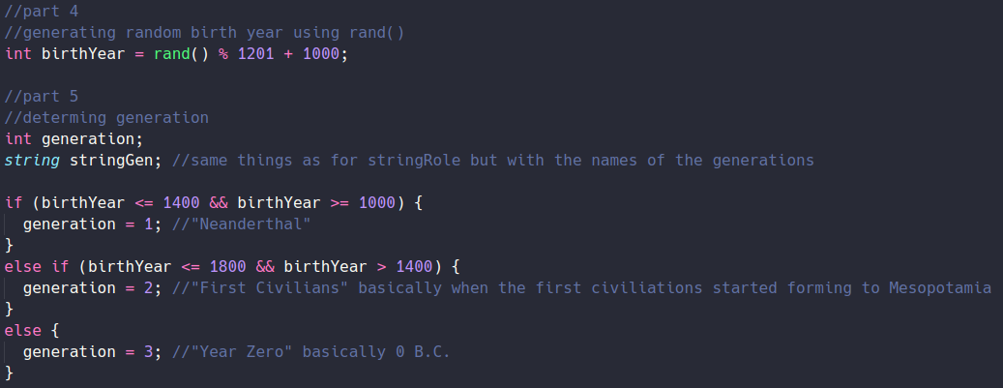Generation 1: Neanderthal

Generation 2: First Civilians

Generation 3: Year Zero

Answers for all options for each role per generation (I have all the answers for each role in a single picture because I just open a copy of the file on the side):

Role 1 Hunter -

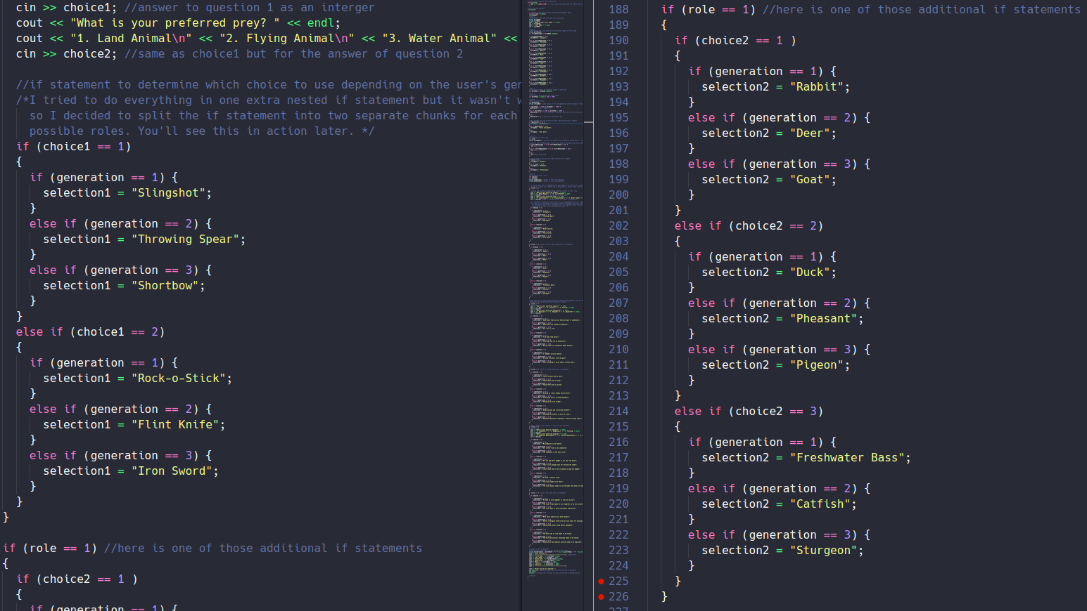

Role 2 Scholar-

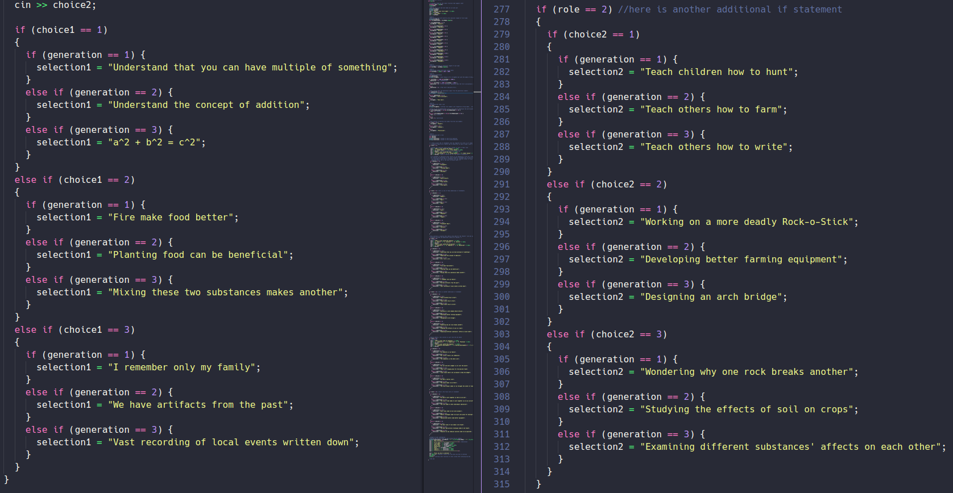

Role 3 Politician -

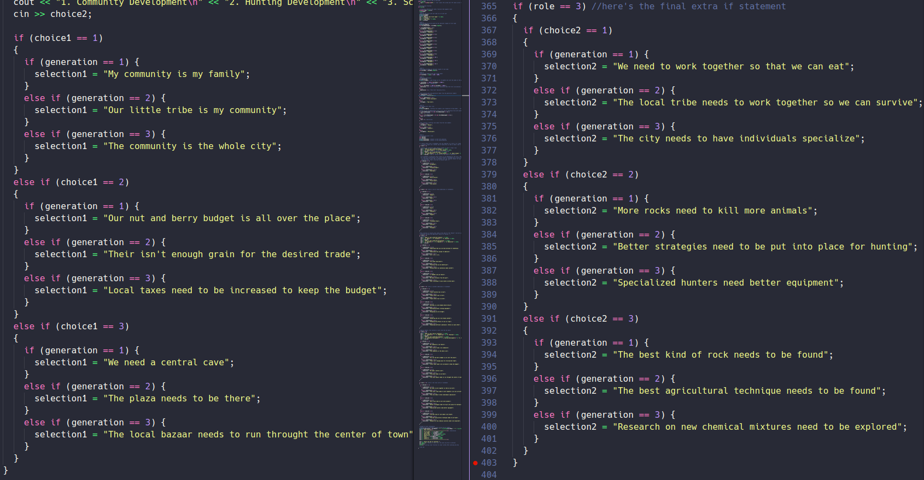

Methods for assigning generation and role to the user:

Generations -

I first assign a seed so that the rand() function will truly psuedo-random

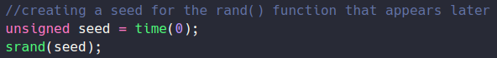I then generate a random year and assign ranges of years to the three generations. The generations are represented by numbers

Finally I create a string with the name of the generaiton that corresponds to the generation number

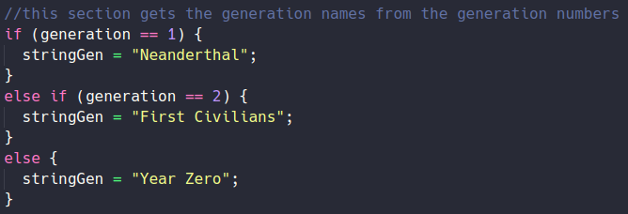

Method used to assign role to the user:

Since the length of the user’s name corresponds to the birth month and I decided to split the roles into 4 month ranges, I decided assign roles to numbers depending on the birth month of the user. Remeber the birth month number is the same as the number of characters in the user’s first name.

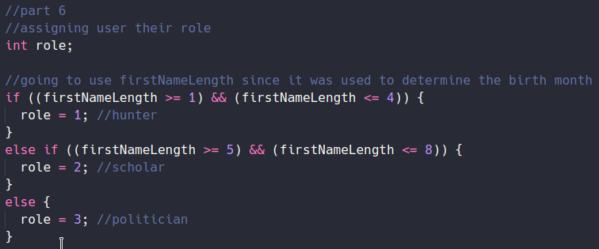I then create a string that with the name of the role that corresponds to the role number

